Policy Roundtable Report

Mark Sanders, Ben Berger, Guy De-Nicolay, Maria-Jose Palomar Oetling

Document Identifier
Annex X to D5.12 The Reform Strategy for Italy, Germany and United Kingdom

Version
1.0

Date Due
M36

Submission date
15-05-2018

WorkPackage
5

Lead Beneficiary
UU

Place, Date and Time
London, 26-04-2018, 11:30-16:00, London School of Economics, London, United Kingdom.

Stakeholders
Name | Organisation
Andrei Suse | Leuven Centre for Global Governance Studies
Angelina Cannizzaro | Department for Business, Energy and Industrial Strategy
Bob Hancke | LSE
Bonnie Chiu | The Social Investment Consultancy & Lensational
Dimo Dimov | Business School, University of Bath
Errko Autio | Business School, Imperial College London
Gary Dushnitsky | Department of Entrepreneurship and Strategy, London Business School
Gilly Wiscarson | Entrepreneurs Accelerator, Kings College London
Jon Deer | LSE Research Division
Jonathan Levie | Hunter Centre for Entrepreneurship, University of Strathclyde
Laura-Jane Silverman | LSE Generate
Luca Zurlo | Managing Director, Voluntres Venture Capital
Mark Sanders | Utrecht University and FIRES
Matt Adey | British Business Bank
Olmo Silva | Department of Geography, LSE
Pamela Dow | Catch22
Al Bhimani | Department of Accounting and former Director of Entrepreneurship Initiative, LSE
Saul Estrin | LSE Department of Management
Professor Siva Thambisetty | Law Department LSE
Stephan Chambers | LSE Marshall Institute
Susana Frazao Pinheiro | Entrepreneurship Centre, University College London
Thomas Hellmann | University of Oxford, Said Business School
Tomasz Mickiewicz | Aston University Business School
Ute Stephan | Aston Business School Business School

Format
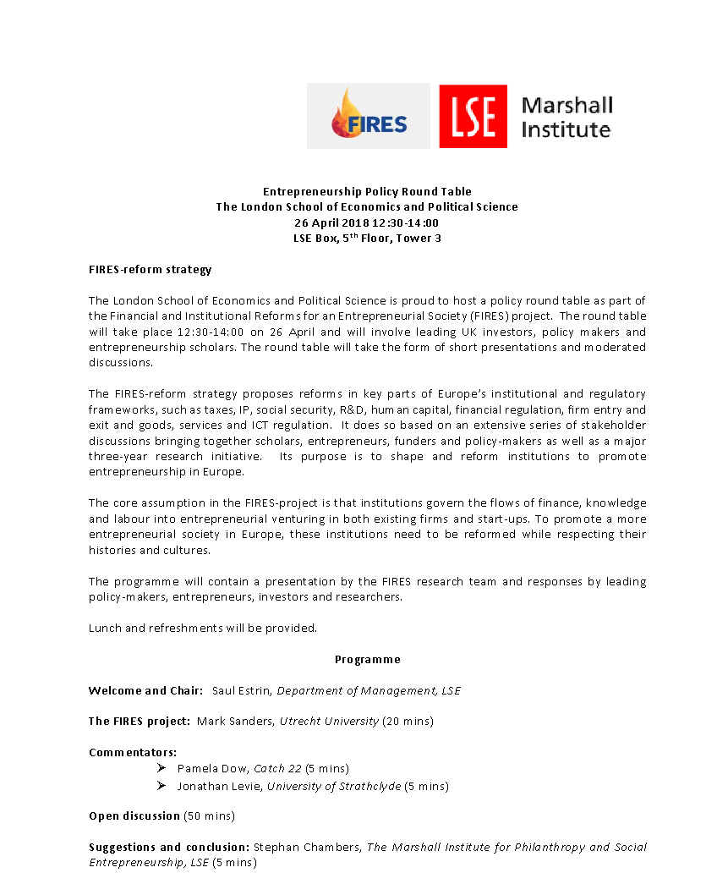
The round table was hosted by LSE’s department of Management and the Marshall Institute, and was organised in three parts. First, after an introduction to the event by Saul Estrin, Mark Sanders presented the FIRES project and its reform agenda for the UK. Then Pamela Dow and Jonathan Levie gave their reflections in a brief discussion. Finally, the floor was opened to the participants for general discussion. Stephan Chambers brought the proceedings to a close. See the program in the flyer of the event below reproduced:

Participants were sent the Policy Brief on the FIRES-reform strategy for the UK one week in advance and asked to reflect on the questions below.

Main Questions put to the Stakeholders
Would you agree with our approach?
Would you agree with our diagnosis?
Would you agree with the proposed treatment?

Summary
As part of the Financial and Institutional Reforms for an Entrepreneurial Society (FIRES) project, experts in the field of entrepreneurship recently met at a workshop in the London School of Economics and Political Science to discuss the reform strategies proposed in the FIRES policy brief on entrepreneurship in the UK.
The FIRES project seeks to propose strategic reforms to Europe´s institutional and regulatory frameworks to benefit entrepreneurship in key aspects such as taxes, IP, social security, R&D, human capital, financial regulation, firm entry and exit and goods, services and ICT regulation. The LSE event permitted leading UK investors, policy makers and entrepreneurship scholars to participate in a round table to discuss the proposed reforms and possible ways to implement them.
The event was hosted and chaired by Professor Saul Estrin who set the scene and welcomed the participants. In his presentation, Dr Mark Sanders, Associate Professor at Utrecht University, presenting on behalf of the FIRES project, highlighted a mostly positive evaluation of entrepreneurship in the UK. The presentation was framed with a medical patient-doctor approach in which the UK was presented as a patient diagnosis with specific symptoms to be treated with certain proposals and recommendations to be made. Dr Sanders pointed out how the UK performs well in comparison to European standards with its entrepreneurial ecosystem of liberalised markets, deep formal financial markets, strong science and knowledge creation and a powerful legacy of protection of intellectual property rights. However, he stressed that while this ecosystem rewards entrepreneurial success it is not very inclusive and resources are highly concentrated in London and South-east. This calls for a need to focus on reforms that will benefit regions around the country – most notably the north of England. Moreover, while the UK is strong on radical innovation and identifying entrepreneurial opportunities, it is weaker in bringing those projects to fruition. The key constraints here include labour skills, incentives for firms to invest in firm-specific human capital, and weaknesses in the supply of early stage entrepreneurial finance. Furthermore, as part of the treatment, Dr Sanders presented a set of three general recommendations based on more open access to knowledge, more inclusive capitalism and levelling the playing field in regional and talent terms.
After Dr. Sanders introductory presentation, Pamela Dow, Chief Reform Officer from Catch 22, and Professor Jonathan Levie from University of Strathclyde shared some brief comments on the presentation. Dow noted how the language on entrepreneurship is mainly focused on the international success stories and fails to include all varieties of entrepreneurs, ranging from multinational fintech startups to the local plumber starting his own business. All of which must be equipped, she stressed, regardless their size and industry, with the basic skills of running their businesses. Additionally, Dow noted that at a national level, there is a visible centralization of the entrepreneurial resources in London, which is now starting to be perceived as a competitor to Tel Aviv or Silicon Valley. Yet, the city is only attracting a narrow demography. Finally, Dow pointed out how process innovation in terms of productivity improvement must be equally valued as the entrepreneurship process itself. She noted how organisations across the private, public and social sector seem to be failing in this matter.
Following Dow´s comments, Professor Jonathan Levie also expressed his deep concern about the centralization of entrepreneurial activity and resources in the UK into London. He illustrated the problem with data indicating a massive increase in company creation and growth in London boroughs such as Hackney (around Silicon roundabout) whereas in other regions of UK the rate of company formation and growth is much slower. Professor Levie discussed how this leads to an uneven distribution of labour force in the UK where there is a lack of incentives for people to stay and/or go back home outside of London to contribute to growing businesses that have severe labour shortages.
These presentations were followed by an open table in which participants provided Dr. Sanders with their responses to the FIRES reforms and discussed how improvements could be made to further develop enterprise on these shores. One of the relevant topics that arose during the discussion was the notion of entrepreneurship itself and the meaning of the term. This was seen as very ambiguous. It was argued that the language of entrepreneurship should be broadened to make it more specific and inclusive so that different types of entrepreneurship from restaurants, to taxi drivers, to industrial production could be independently identified, and effectively addressed by specific corresponding policies.
Additionally, an important note was made towards including a discussion of failure not only in the FIRES report analysis but also in the language of entrepreneurship more generally because understanding how and why ventures fail is a very relevant issue that does not seem to be currently sufficiently addressed. Policies to reduce failure and accelerate scale-up were proposed to be as important as policies to generate more entrepreneurship. It was argued that in the US start-ups may grow more rapidly while in Germany, there might be fewer start-ups but they would be more likely to survive and prosper. There was a need to focus on learning from failure in the entrepreneurial process.
The discussion also revolved around the FIRES proposals on experimenting with open IPR to ensure access to and commercialization of knowledge (Proposals number 2 and 5). The participants questioned the proposal of abandoning IP protection and pointed out that regulation regarding patents seems more relevant as it is what is in fact blocking growth. It was argued that while Intellectual Property is important, patents are more important. Regulation regarding standing patents were seen as blocking growth by allowing patent protection to continue for many years. It was suggested instead that one could either increase renewal fees of patents, or open ‘IP’ systems to radical change towards “Open Source”. This system would then mirror that of, for example, the culinary industry where informal structures which respect the ownership of recipes, for instance, encouraged activity, competition and entrepreneurship without legally blocking innovation. Also, infringement was seen as too sharp a term; if you encourage infringement, you might encourage entrepreneurs that have the wrong incentives. Additionally, some participants pointed out the importance of keeping IP laws to encourage investment as it is one of the few tangible components of an entrepreneurial project upon which investors can make evaluations about where they should put their money.
On a different train of thoughts, some issues were pointed out not to be sufficiently addressed such as immigration, human capital and digitalization. For example on immigration, it was argued that what makes Silicon Valley unique is the specific socioeconomic condition, the structure. The people who built up Silicon Valley were not American, they were largely European and Asian. Many Europeans came there because of the entrepreneurial environment and the strong Venture Capital market. This led to a general discussion revolved around the importance of building up an integral ecosystems with a dynamic entrepreneurial environment and a much more inclusive venture capital investment approach.
After the end of the round table, Stephan Chambers from The Marshall Institute for Philanthropy and Social Entrepreneurship from LSE summarized the key points and presented some personal reflections to round up the discussion. First, he noted that the UK system based on markets forces with policies centred on deregulation may have begun to reach the point of diminishing returns; it may be time to consider some more pro-active government policy making along the lines of the FIRES Report. Second, he picked up on the importance of a more inclusive and modular entrepreneurship language, allowing for the differences in forms and types of entrepreneurial activity. Third, Chambers discussed the curse and blessing that political and policy centralization represents in the UK because it depletes regional energy and distorts national culture. Finally, he noted that entrepreneurship policy must become granular to enable the focus on the different challenges entrepreneurship poses.
As a concluding remark, Chambers also shared his personal reflections which revolved around the need of development a benchmark that enables this study to better evaluate the findings by comparing it to what is happening in the rest of the world. Finally, picking up on what was previously discussed during the round table, he noted on the importance of evolving this conversation towards transcending a purely entrepreneurship approach that manages simultaneously to include the process innovation challenge.

Follow Up
After the discussion with the UK policy makers and researchers there will be a final revision of the policy brief and country report to be submitted as parts of deliverable D5.12 on M36. Also the discussion in London serves as input for D6.3 in M36.

Pictures of the event
