Policy Brief on the FIRES-Reform Strategy for Italy

Mark Sanders, Luca Grilli, Andrea Herrmann, Gresa Latifi, Balazs Pager, Laszlo Szerb and Elisa Terragno Bogliaccini

Document Identifier
Annex to D5.12 An institutional reform strategy for Germany, for Italy, and for the UK

Version
1.0

Date Due
M36

Submission date
01-03-2018

WorkPackage
5

Lead Beneficiary
UU

Financial and Institutional Reforms for Entrepreneurial Society (FIRES)

Policy Brief on FIRES-Reform Strategy for Italy
Authors: Mark Sanders, Luca Grilli, Andrea Herrmann, Gresa Latifi, Balazs Pager, Laszlo Szerb and Elisa Terragno Bogliaccini

No. 2018-02/March 2018

Abstract

In this policy brief we outline a draft FIRES-reform strategy to promote an Entrepreneurial Society in Italy. The reforms proposed are derived from a seven-step process in which the academic work and stakeholder engagement activities of the FIRES-project come together. This seven step process was applied to the case of Italy in a report (download here) and this brief summarizes its findings. Italy was selected to be representative for a Mediterranean and so called mixed market economy. This brief is one of three, where the other briefs address the United Kingdom and Germany.

Introduction:
In this brief we present the FIRES-reform strategy for Italy. In the FIRES-project we developed a seven step approach to tailor a reform strategy to a specific situation (see box 1 below). In this brief we present the results of steps 1 to 5. Step 6 will be presented in a separate report on the results of the policy round tables where this draft reform strategy is discussed. Our method up to step five can be likened to the way in which a medical doctor would diagnose a patient. He/she would combine detailed knowledge about the patient’s character and most recent medical history, data from diagnostic tools and an in depth discussion with the patient about his or her symptoms. After diagnosing the patient, the doctor will then prescribe, from an established arsenal of effective treatments, those he or she feels most fitting for the patient and his or her condition. In section 1 you will thus find a brief summary of our diagnosis for Italy. This is based on a triangulation of historical analysis, quantitative data analysis and qualitative information from founder surveys, desk research and expert opinion. In section 2 we present our proposed treatment in the form of our proposed reforms. Section 3 concludes.

Box 1: The FIRES seven step approach
The FIRES seven step approach
Step 1: Assess the most salient features of the institutional complex in place and trace its deep historical roots (WP2).
Step 2: Assess the strengths and weaknesses and flag the bottlenecks in the entrepreneurial ecosystem using a structured data analysis (WP4).
Step 3: Identify, using careful primary data collection among entrepreneurial individuals (i.e. founders) what most salient features characterize the start-up process and where entrepreneurs face barriers (D5.1).
Step 4: Map the results of step 2 and 3 onto the menu of policy interventions developed in Part I of this report to identify potential interventions for the country under investigation.
Step 5: Carefully consider the list of proposals in light of the historical analysis under step 1 and fit the proposed reforms to the relevant local, regional and national institutional complex in place.
Step 6: Identify who should change what in what order for the reform strategy to have the highest chance of success (WP6).
Step 7: Experiment, evaluate and learn and return to step 1 for the next iteration.

Section 1: The patient and our diagnosis
The FIRES-project started out by establishing that one-size-fit-all approaches to promoting an entrepreneurial society are unlikely to be successful. Making a society more entrepreneurial involves reforming its institutions such that more of society’s resources flow into experimental, new venturing. But if it is institutions that need to be reformed, then we have to realise that institutions have deep historical roots and never operate in isolation. In the complex web of interacting institutions that makes up the entrepreneurial ecosystem, we need to first identify which elements can be reformed and which ones we need to take as given. For Italy we conclude, from our historical analysis, that many of the institutions that are considered important in an entrepreneurial ecosystem, have deep roots. Already in the Renaissance, Italy saw the emergence of banking, patents and universities. We can also trace its corporatist tradition in labour relations to the long presence of the Catholic Church that still has an important influence on the Italian welfare arrangement and social security system. The Italian labour relations have also been shaped by a strong and militant communist worker movement. This led the Varieties of Capitalism literature to classify Italy as a Mixed Market Economy among the Mediterranean rather than a Coordinated Markets Economy among the Continental Economies, although Italy has one leg in both (e.g. Dilli et al. 2018). Against this background, it is advised not to treat Italy as a blank canvas, but rather suggest policies and reforms that fit this rich and proud historical heritage.

Knowing the patient’s history, we can proceed with the examination to identify the most important bottlenecks and weaknesses in the entrepreneurial ecosystem. A combination of quantitative and qualitative information is required to come to a complete diagnosis. The quantitative analysis is based on the Global Entrepreneurship Index and its regional equivalent, the Regional Entrepreneurship and Development Index (Acs and Szerb 2012). The technical details behind constructing these indices are explained in detail in FIRES-reports D4.1, D4.2 and D4.4. Using an algorithm that converts the raw data into normalized scores per pillar GEI/REDI allows us to assess a country’s or regions’ relative performance. The algorithm also applies a “penalty for bottleneck” to reflect the importance of developing all relevant aspects of the ecosystem in a balanced way. Leaving the technical details in the black box (as a doctor would when looking at a PET-scan) we simply present the resulting plots for Italy and its NUTS-2 regions in the radar-plots below.

Figure 1: Average GEI-scores 2012-2015
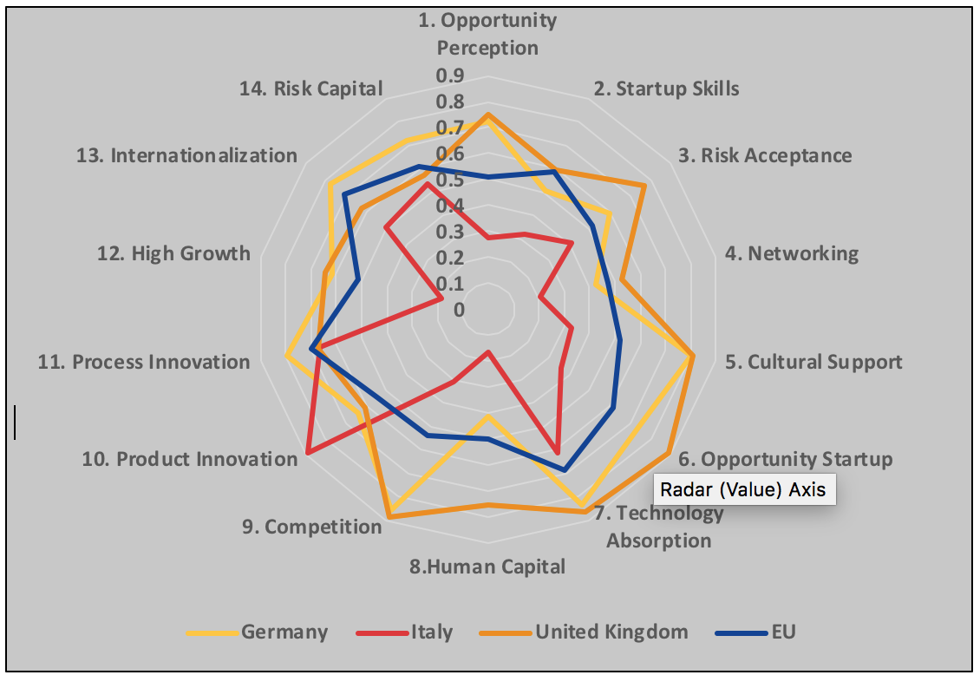

Figure 1 above shows that Italy has a rather unbalanced entrepreneurial ecosystem. It excels in product and process innovation, but this strength is negated by its lack of High Growth entrepreneurship and Human Capital. Italy also lags significantly, relative also to the EU average, on all pillars that relate to Entrepreneurial Attitudes (pillars 1 to 5).

Figure 2: REDI-scores Italian Regions
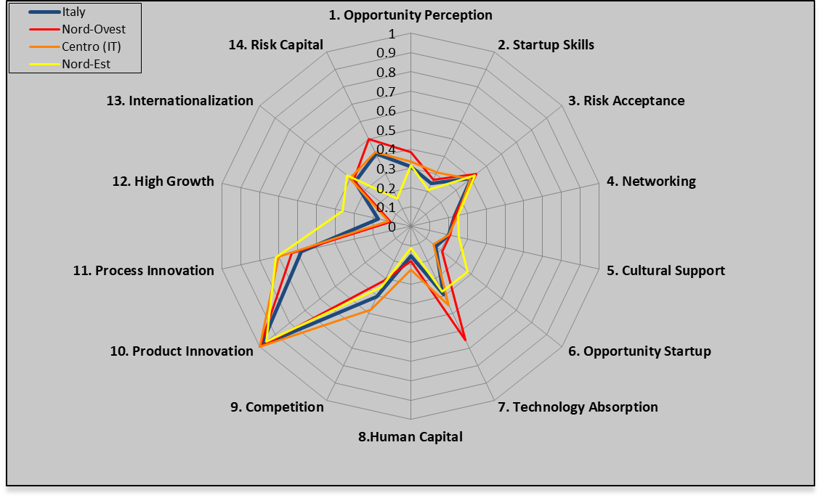
This pattern is repeated when we look at the Italian NUTS-2 regions, as in Figures 2 and 3 and we benchmark them against 125 NUTS1/2 regions in 24 countries.

Figure 3: REDI-scores Italian Regions
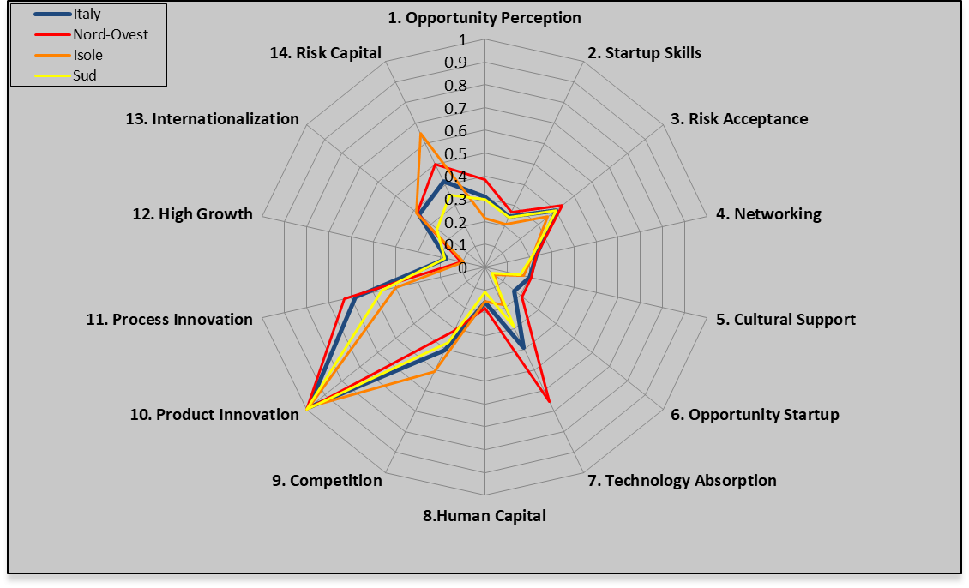
In Figures 2 and 3 we observe the same unbalanced entrepreneurial ecosystem, explaining a relatively low score on the overall index for Italy (with 41.4, it is ranked 30 out of 65 developed and emerging countries, between China and Puerto Rico or Slovakia and Latvia in Europe).

Figure 4: REDI-scores 125 EU NUTS1/2 regions
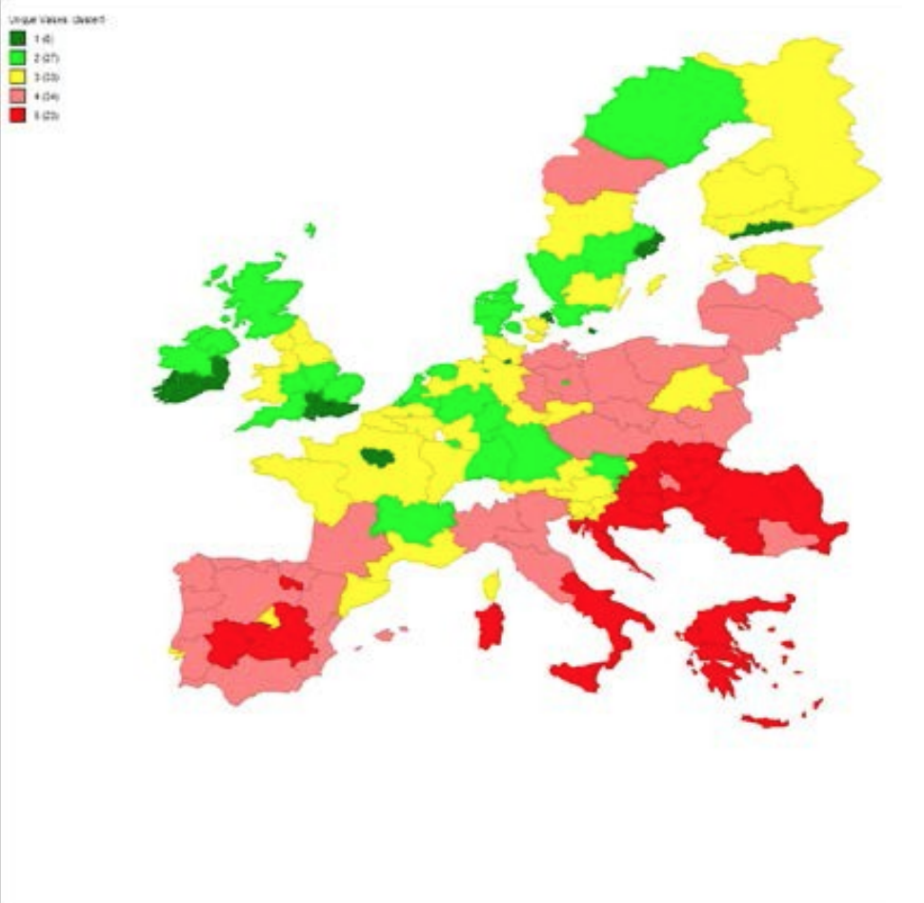
Figure 4 shows how the Italian regions compare to regions in the rest of Europe. By looking at these numbers, it is clear that reforms to strengthen the Italian entrepreneurial ecosystem are both urgent and desirable.

Table 1: REDI Report Card Centro
 | PILLARS |  | INSTITUTIONAL VARIABLES |  | INDIVIDUAL VARIABLES
Entrepreneurial  Attitudes | Opportunity perception | 0.34 | Market Agglomeration | 0.46 | Opportunity Recognition | 0.57
 | Start-up skills | 0.31 | Quality of Education | 0.65 | Skill Perception | 0.34
 | Risk Acceptance | 0.39 | Business Risk | 0.69 | Risk Perception | 0.37
 | Networking | 0.25 | Social Capital | 0.46 | Know Entrepreneurs | 0.37
 | Cultural support | 0.20 | Open Society | 0.35 | Career Status | 0.85
 | Entrepreneurial Attitudes 28.1
Entrepreneurial Abilities | Opportunity startup | 0.15 | Business Environment | 0.27 | Opportunity Motivation | 0.67
 | Technology Absorption | 0.45 | Absorption Capacity | 0.37 | Technology Level | 0.85
 | Human Capital | 0.23 | Education and Training | 0.45 | Educational Level | 0.39
 | Competition | 0.48 | Business Strategy | 0.90 | Competitors | 0.35
 | Entrepreneurial Abilities 29.9
Entrepreneurial  Aspirations | Product innovation | 1.00 | Technology Transfer | 0.79 | New Product | 1.00
 | Process innovation | 0.70 | Technology Development | 0.57 | New Technology | 0.96
 | High growth | 0.12 | Clustering | 0.40 | Gazelle | 0.38
 | Globalization | 0.40 | Connectivity | 0.65 | Export | 0.55
 | Financing | 0.43 | Financial Institutions | 0.56 | Informal Investment | 0.64
 | Entrepreneurial Aspirations 42.6
 | REDI | 33.5 | Institutional | 0.54 | Individual | 0.59

Moreover, the REDI-scans indicate that Italy should concentrate its efforts on improving some specific aspects of its entrepreneurial ecosystem. Table 1 above gives the more detailed breakdown or REDI-report card for the Centro-region. It turns out that the Italian regions are quite comparable in the relative strengths and weaknesses relative to other regions in Europe (see the other regions report cards in the full country report here). We can use table 1 to illustrate how this report card can be used to identify the areas in which institutional reform is urgently advised. For example, the score on the pillar on “High Growth” signifies that in Centro the score on this pillar is only 12% of the highest score observed in 125 European NUTS-2/1 regions on this pillar. The pillar combines information on Clustering (0.40) in the region with the prevalence of Gazelle start-ups (0.38) among the new firms founded in the region. Using an algorithm that combines the scores on individual agency and institutional quality, a score per pillar, per sub-index and ultimately for the entire region is computed. At every level, the algorithm rewards a balanced development within and across pillars and punishes the score when bottlenecks are present. The low scores are marked red.
In Entrepreneurial Aspirations, the low score on “High Growth” signals that in Centro the aspirations to found high growth firms are a constraint on high quality entrepreneurship in general. We see this bottleneck is also prevalent in other Italian regions, suggesting perhaps national policy action is called for. As the individual variables reflect responses of individuals to their institutional environment, this red flag suggests we should think about policy interventions and institutional reforms that promote cluster formation (as clusters tend to stimulate high growth start-ups in particular) but also other interventions that would stimulate firm growth, in particular in small and young firms. Labour market reforms as proposed under the recent “Jobs Act”, can for example be beneficial in removing the penalty on growth that is present in many firm size related social security and labour market protection provisions. It will probably take some time for such reforms and interventions to show up in the report card, as the numbers will only change when people respond to the new situation by starting more ambitious and successful firms. Still the FIRES-consortium would suggest that such fundamental reforms are preferred over more direct but less fundamental policies that would boost the indicators directly.
Similarly, the report card flags “Human Capital” and “Opportunity Driven Entrepreneurship” as weaknesses in the Entrepreneurial Abilities, whereas in Attitudes, the pillars “Networking” and “Cultural Support” reduce the overall quality of the entrepreneurial ecosystem. For human capital both educational level and training warrant attention, whereas for opportunity driven entrepreneurship it is especially the poor quality of the business environment that keeps the pillar down. Italian entrepreneurs seem to see opportunities, but are held back by deficient human capital and a daunting bureaucracy in starting up new ventures. To address these weaknesses, targeted interventions to improve the business environment will be needed, whereas reforms in the educational system are also urgent. Not because the Italian education system does not deliver high quality graduates, but because that quality does not seem to flow into entrepreneurial venturing, either as founders/ entrepreneurs or as employees. Recent efforts to liberalise the labour market have yet to show their effectiveness to improve this.
In Entrepreneurial Attitudes, the pillar on Networking is weak because of a lack of successful role models (individual), whereas the Cultural Support pillar is weakened by the low system wide score on “Open Society” that negates the relatively high score for career status. It is not straightforward to come up with reforms that improve these aspects but below we will make some suggestions.
From our analysis of recent policies in Italy, we can conclude that the entrepreneurship policies, aimed primarily at supporting investment and diffusion of new technology in SMEs in manufacturing, has indeed paid off. Moreover, the set of measures embodied in the “Decreto Crescita 2.0” (Italian Startup Act) launched in the late 2012 surely represented a significant step forward.
But like an athlete training only some muscle groups, it seems Italy has ignored some other highly relevant aspects of the entrepreneurial ecosystem. We will therefore propose some targeted interventions to strengthen these weaknesses and make Italy the all-round athlete it needs to become to perform better. Before one turns to treatments, however, it is also advised to listen to what the patient has to say. In a survey among 130 founders in Italy, we collected responses on a list of questions, of which the open question on barriers to founding gave us an opportunity to triangulate the information from the quantitative analysis with more qualitative information.

Table 2: Responses Survey
Regulatory Obstacle | Times mentioned
Which regulatory requirements did you perceive as major obstacles during venture creation? | 131
None | 28
Difficulties with bureaucratic procedures | 19
No answer | 13
Taxes | 7
Difficulties with obtaining finance | 7
Lacking clarity regarding regulations | 5
Constantly changing regulatory environment | 5
Safety regulations | 5
Legal requirements to involve a notary | 4
Legal Initial Capital Requirements | 3
Specific requirements related to energy sector | 3

After coding the answers, Table 2 presents the top-10 most mentioned issues in this open question. First, we can conclude that the survey results largely confirm the picture that emerged from the REDI-data. Italy has a challenging business environment due to a daunting and complex bureaucracy. As a consequence, entrepreneurs see few opportunities for high growth venturing and those that do start up mention high taxation and limited access to financial resources as additional barriers to growth. In the top-10 we see that the founders confirm the problem of a poor quality business environment. Many mention bureaucracy and complicated legal and regulatory requirements to start a firm. It seems it is unclear how and rather complicated to start a venture in Italy. As we have argued in earlier reports, some barriers to entry can be justified and work to increase the quality of start-ups that overcome such barriers. From the survey, however, we do not get the impression that this is how the current Italian barriers to entry work. We should, however, not over interpret these results. The survey is useful in confirming and nuancing some of the results we obtained above.

Section 2: The proposed treatment
In our report we have considered the medical history of the patient, used an advanced diagnostic tool to scan for her health problems and asked the patient how she felt. It is not uncommon for patients to also suggest remedies and treatments themselves. In our survey among Italian founders, we also posed the open question: “In your view, what could policy-makers do to facilitate venture creation?” The results of that survey were coded and the nine answers that were mentioned more than twice are listed in Table 3.

Table 3: Responses Survey
Policy Suggestions | Times mentioned
What could the government do to promote new venture creation in Italy? | 99
Reduce bureaucracy | 21
Facilitate financing for small businesses | 16
Reduce time and difficulty of bureaucracy through online procedure | 7
Provide better information about how to start a business | 7
Provide better training to people for starting businesses | 6
Reduce tax rates for small businesses | 5
Provide guidance | 4
Provide incentives for hiring people | 4
Avoid constant policy changes | 3

It seems founders in Italy stick to traditional medicine and propose a variation on the inform, fund and deregulate approach that has been propagated for decades now. These things remain important for a healthy entrepreneurial ecosystem, as much as not smoking, sports and a healthy diet are important for a cancer patient. But this alone will not cure the more fundamental problems we identified above. Based on all the information available we can come to a full diagnosis and mapping that diagnosis onto the menu of available treatments (downloadable here), we propose a treatment that fits our patient and her condition.
Italy has a long and proud history. Many of the institutions that shape an Entrepreneurial Society have their roots in Italy. Italy has seen the birth of modern banking, invented intellectual property rights protection and boasts the oldest universities in the world. Even today Italy boasts a highly innovative small and medium sized entrepreneurial sector that competes on quality at the global level. Innovative entrepreneurship has deep historical roots in Italy. But time has progressed and the landscape has changed. To face the challenges of the future, Italy will have to build on its strengths and should urgently address its weaknesses. Where Italy could strengthen its entrepreneurial ecosystem is in the area of boosting human capital investments and more importantly, opening up opportunities for the young and talented to engage in productive and innovative venturing in Italy. Italy has seen in the recent crisis, but also before, an exodus of talent. It seems there are more opportunities abroad than at home. And of those that do stay and start-up ventures, most complain about cumbersome bureaucracy resulting in lacking growth ambitions and stunted economic dynamics. Taking these ailments to our menu of policy interventions and reform proposals in Part I of this report, we selected the fifteen most suitable interventions. They are listed in Table 4 in the Appendix. In column 1 we find the number under which they were presented in Part I of the full report (downloadable here) and column 2 gives the section number in that report where one can read more of the background and general motivation for the proposals. Column 3 lists the title and 4 the full proposal, where column 5 gives a short motivation linking the proposal to the analysis presented above and column 6 fits it into the Italian context.
Proposal 1 seeks to address the complexity of the Italian legal system. Procedures take too long and more importantly, this differs markedly across the territory. We believe it would help not only entrepreneurs in Italy when the judicial system effectively settles disputes and while progress is being made, this remains an important area of reform. A stable and predictable system of Rule of Law and high quality government is essential for any Entrepreneurial Society and an effective judicial system is essential to ensure it.
Proposals 8 and 10 seek to address the tax burden on especially growing firms. Italy has generous tax exemptions for SMEs, but should evaluate the tax burden over the entire lifecycle of firms. A fiscal penalty on growth is to be avoided. More important than low statutory tax rates, are clear, transparent and predictable tax liabilities. With an overall tax pressure of 64% (against 40% in the EU on average), a general reduction in corporate income taxation is probably wise as well. It is better to have low taxes on broad tax bases by making
Proposals 14 and 19 seek to strengthen the flow of financial resources into entrepreneurial venturing in Italy. We do not focus on the Anglo-Saxon angel and VC model of venture finance, but rather aim to strengthen Italy’s traditionally strong arms-length banking sector and the flow of private wealth through strong family ties.
Proposals 28, 31, 32 and 35 seek to improve the mobility of talent while at the same time maintaining the level of social security that Italians value highly. That is, given the high levels of risk adversity, it seems prudent to not create the much needed flexibility by just liberalising labour markets, wage formation and social security. Instead, we propose measures that are closer to the flexicurity systems which Coordinated Market Economies are testing. Moreover, Italy could try to enhance the mobility of its labour force over sectors and occupations by investing in training and lifting legal barriers to such mobility.
Proposals 40, 45 and 48 address the cumbersome regulatory barriers to starting and growing firms in Italy, while at the same time setting up knowledge centres or “Observatories” to support such venturing. At the same time Italy should reduce the complexity and opacity of regulation and develop one-stop-shops for entrepreneurs that need help navigating the regulatory requirements that remain.
Proposals 55, 57 and 59 seek to reform the Italian education system in the direction of a more flexible, mobile, modern and creative type of graduate. The set of skills that current cohorts of pupils and students need to succeed in a globalised and open European economy is not easy to put down in a curriculum. But creativity, out-of-the-box thinking and communication skills help Italian youngsters be the jacks-of-more-trades that entrepreneurial ventures look for.

Section 3: Concluding remarks
The proposals, individually and in combination, aim to strengthen the knowledge base and talent pool from which Italian entrepreneurs can draw and aim to open opportunities for not only starting but also growing firms in all regions in Italy. All regions stand to benefit from these interventions. But, due to the fact that density and clustering tend to promote the quality and impact of entrepreneurial venturing, the same policy improvements will probably benefit already prosperous regions most. Nevertheless, that should not stop policy makers from pursuing these interventions as it is the Italian citizens, not its regions per se, that the national government should care about. It is advisable, however, to also set up automatic transfer systems that will help maintain high quality of life throughout the country.
Of course these proposals will need a much more detailed discussion and only form the starting point, not the final word in the policy debate. Moreover, even if eventually adopted, our proposals all require careful implementation and evaluation to complete the 7-step policy cycle presented in Box 1. But based on our analysis of the situation, we propose the patient consider this set of interventions to restore health to its ailing entrepreneurial ecosystem.

Sources and further reading:

References:
Acs, Z. and L. Szerb (2012) Global Entrepreneurship and Development Index, Cheltenham: Edward Elgar Publishers.
Dilli, S., Elert, N., & Herrmann, A. (2018). Varieties of entrepreneurship: exploring the institutional foundations of different entrepreneurship types through “varieties-of-capitalism” arguments. Small Business Economics. Forthcoming
Worldbank (2018). Doing Business 2018. Washington DC: Worldbank. Downloadable here.

All FIRES-reports and policy briefs on:
www.projectfires.eu

Most relevant FIRES-deliverables:
D4.1 Report on the Extension of the GEDI-Indicator
D4.4 Regional Entrepreneurship and Development Index: Structure, data, Methodology and Policy Applications
D5.1 Report on Start-up Processes in Italy, Germany and the UK
D5.6 Case study on Italy’s Young Innovative Companies Program
D5.12 Part I: The FIRES Reform Strategy
D5.12 Part II: The FIRES Reform Strategy for Italy

Disclaimer: This project has received funding from the European Union’s Horizon 2020 research and innovation programme under grant agreement No 649378. This policy brief express only the author's views and that the Agency is not responsible for any use that may be made of the information it contains.

Appendix
Table 4: Proposals for Italy
# | Section | Title | Proposal | Explanation | In Italy
1 | 3.1.2 | The Rule of Law | We propose to further strengthen the current rule of law monitoring and enforcement mechanisms to ratchet up the performance of all Member States on issues related to rule of law, government effectiveness and protection of property rights. | Deficiencies in these factors negatively impact all agents in the entrepreneurial ecosystem and induce people to conduct activities and keep their capital in the shadow economy. Even the poorest EU member countries are higher medium-income countries, and neither the VoC literature nor arguments à la Rodrik (2008) provide any support for the view that these countries can compensate for these deficiencies through other institutional measures. | It takes too long to settle commercial disputes in civil cases. This creates uncertainty and works in the advantage of large, established and incumbent firms. An entrepreneurial society needs fast, predictable and clear legal proceedings to thrive. A lot has been done, but more is needed still.
8 | 3.2.4 | Taxation of Corporate Income | The Union should strive to reduce and ideally remove the discrepancies in member countries between statutory and effective corporate income tax rates, which may result from tax-reducing depreciation rules, inventory valuation rules or other more ad hoc country- or industry-specific tax reductions. | Their removal would create transparency and contribute to levelling the playing field for all firms regardless of their size, age, industry or nationality. Competition among member states is good, but it should be competition on corporate tax rates and not on complex, opaque fiscal deals and schemes. Moreover, when it comes to corporate taxation, member states should treat all firms equally. | This general advice we would give to the Comission and would also apply to Italy. Founders in Italy complain about taxes but more than their level, their complexity and unpredictability makes growing a firm unattractive.
10 | 3.2.5 | Taxation of Dividends and Capital Gains | Complexities should be removed when possible. Instead, countries should aim for dividend and capital gains tax rates with few exceptions and few (opaque) concessionary schemes. | Here, the Eastern European countries, such as Poland and Estonia, have exemplary models in which the tax rates are at reasonable levels and the effective tax rate is largely independent of other circumstances. Arguably, the reason for this clarity is that the design of these systems date back no further than 1989. A radical redesign from the ground up is probably not feasible in older member states, but they should nevertheless strive for similar improvements to simplicity and transparency. | See proposal 8. A tax system benefits from an occasional cleaning-up. Simplicity and transparancy should be the goal, not necessarily reducing rates for targetted groups. But at an overall tax pressure of 64% against 40.8% in Europe, Italy should also reduce taxes.
14 | 3.3.2 | Private Wealth | Our proposal is that in regions where family ties are strong, there should be institutional arrangements that would promote lending from private funds especially from the family to ventures. | In FIRES-Deliverable 2.2 (Dilli and Westerhuis 2018) it was shown that these cross-national differences in family financing are result of the differences in extent to which individuals feel socially obliged towards their family members, shaped by the strength of family ties. These family ties are result of the historical family arrangements. As a result, the share of family financing is expected to be much higher in regions where traditionally the family group has priority over the individual (strong family ties), common in the Eastern European and the Mediterranean countries context compared to the North Western European countries where the individual and individual values have priority over family (weak family ties). | Italy has a strong family based tradition. This creates opportunities also for financing ventures, especially in their early stages. Italy could consider banking on extended family ties to increase the flow of financial resources into entrepreneurship. The Anglo-Saxon Angel and VC model may be less appropriate in the Italian context.
19 | 3.3.4 | Banking | Increase the mandatory equity ratio in banking gradually to 10-15% to have more skin in the game and allow banks to take on more risk responsibly in their lending portfolios. | Given that European banks operated profitably at much higher equity ratios in the past whereas non-European banks continue to do so, this proposal only requires a sound implementation and transition strategy. Gradually building up the equity buffer while at the same time accumulating more publicly guaranteed SME-loans in the portfolio is a balanced approach. Higher required equity buffers will increase the price of credit and some might argue that this will reduce credit and investment in the aggregate. We feel, however, that such price increases will only drive out the marginal investment projects and most of these are currently found in the secondary, speculative investments that Bezemer (2014) deems unproductive. | Italy still has a rather diverse and locally embedded banking system. This can be an asset in the entrepreneurial society, but these small, local banks are increasingly brought under European rules and supervision made for large, system banks. By requiring higher equity in banks, they can justifiably engage in riskier but also in the long run more productive lending.
28 | 3.4.2 | Employment Protection Legislation | CMEs can provide a model for MMEs, which show more similarities to CMEs in many respects than LMEs. | Less regulation on permanent employment is likely to be linked with high-growth aspirations among entrepreneurs particularly in the Mediterranean Market Eeconomies (MMEs) whereas no change is observed in the other institutional constellations. Given that Coordinated Market Economies (CMEs) are shown to perform rather well in innovative entrepreneurial activity, while being characterized by moderately liberal labor market institutions, centralized wage setting institutions and high levels of social security. We therefore conclude that a policy of radical liberalisation following the Liberal Market Economies (LMEs) model is perhaps not the only way. | Italy has already implemented some fundamental reforms in the labour market in recent years. In part this was done under pressure of the financial and eurocrisis and external creditors. The general direction of these reforms was right, but Italy should not forget that of the MMEs it is actually closest to the CMEs and should seek to combine flexibility with social security.
31 | 3.4.3 | Employment Protection Legislation | Establish or strengthen training programs to prepare workers for new occupations | Archanskaia et al. (2017) show that countries with a low rate of substitution between inputs in routine production, will not be able to gain a comparative advantage in high-value products that are intensive in non-routine tasks. As a result, they will end up specializing more and more in routine-intensive products and experience lower wage growth. Geurts and Van Biesebroeck (2016) further show that the pattern of firm-growth in Belgium indicates that young firms under-adjust to good news. As a result, many promising firms scale up too slowly and they might miss out on opportunities in a fast-paced global market. | In a more flexible labour market, more flexible and mobile employees are key. Italy will not be isolated from technological and economic trends and flexibility is needed to engage opportunities and exit declining jobs, industries and trades. We propose Italy invests in the flexibility of its workforce.

# | Section | Title | Proposal | Explanation | In Italy
32 | 3.4.4 | Confidentiality Agreements and Barriers to Mobility | To promote the mobility of people and their knowledge across firms, we propose to lift the legal enforceability of confidentiality agreements between employers and their employees. | Of course, there can be justified instances in which confidentiality is needed to protect the legitimate interests and privacy of customers, but confidentiality agreements and especially non-compete clauses are more often used to prevent knowledge from flowing freely between firms and sectors. | Specifically for Italy, this proposal should be understood in light of the two above, arguing for investment in mobility and reducing barriers for switching jobs, industries and occupations. This will create opportunities for the young and talented to remain actively engaged in Italy and reduce the brain drain to the rest of Europe. Specifically the "reinstatement" provision in employment protection is often mentioned as a burden on small and young firms.
35 | 3.4.5 | Social Insurance Systems | Embracing the principles of flexicurity, we propose to carefully consider the impacts of reforms on young SMEs and not force them to take on high risks and burdens. | The general guiding principles the European Commission have formulated do not include structural and careful attention to what such reforms would mean for start-ups and young SMEs. While the specifics can and will vary country by country, we can infer that an important component of a policy that makes society more innovative and entrepreneurial involves making the individual’s social insurances as portable as possible when changing jobs and moving between salaried employment and self-employment. | It is tempting for governments with tight budgets to have employers pick up the bill for their employees' social security. This, however, tends to reduce mobility and strengthens the insider-outsider effect. On the labour demand side, such schemes work in (relative) favour of large firms and blocks young firms expanding. This keeps youth unemployment up and pushes also educated Italian youngsters to leave.
40 | 3.5.2 | Product Market Regulation | Excessive barriers to new business formation and new entry should be lifted where possible. | This, however, seems to be part and parcel of the EU policy agenda already. Our consortium supports that effort with the caveat that well justified barriers to entry are useful to keep unproductive or even destructive ventures out (Stenholm et al. 2013; Darnihamedani et al. 2018). It should be easy for challengers to enter (and exit) but these challengers should be serious. | Key in this proposal is "excessive". Founders in Italy report quite a wide variety of bureacratic and administrative barriers to starting up a venture in Italy. Some of these barriers may serve a valid purpose, but simplicity, transparancy and predictability are then required also. Data shows Italian SMEs spend 52% more time dealing with bureaucracy than their European competitors and WEF ranks Italy 44th on doing business index. There is a lot of room for improvement.
45 | 3.6.3 | Knowledge Diffusion after Failure | We propose to set up publicly funded “entrepreneurial knowledge observatories” where knowledge accumulated in the entrepreneurial process is collected, curated and freely diffused. | Our consortium agreed that a lot of useful knowledge, perhaps of a more applied and tacit nature, is generated in the entrepreneurial process, particularly when ventures fail. That knowledge is lost when entrepreneurs do not share their experiences. However, as that is not their core business and private incentives are absent, it makes sense to publicly fund the collection, curation and diffusion of that knowledge. | Creating a real hub, rich in events, infrastructure, and networking between teams could be useful for the Italian Startup Ecosystem. This involves concentration. Today Milan (14,7%), Rome (8,5%) and Turin (4,7%) have less than 30% of the total number of startups (and these data are flattered). Our research has shown how geographical proximity is important for success. It is a tough choice, but it would be useful to invest in a start-up capital (Milan) with a national function.
48 | 3.7.2 | Knowledge Generation | Both the EU and its member states should create healthy, well-funded, academic institutions that allow Europe’s best and brightest to pursue their research interests. | In the literature, there is also broad consensus that basic research is a pure public good (Salter and Martin 1991; Pavitt 1991). It therefore makes perfect sense to channel more of the EU budgets to an activity that provides such evident positive spillovers throughout the Union. | For the Italian context it is important to open up its academic institutions. Many reforms have already been undertaken, but most in a time of ageing, financial constraints and budget cuts. With vested interests and gilded contracts hard to reform, the rate at which Italian academic institutions open up for competition and meritocracy is slow. It makes little sense to spend a lot of money on institutions before such structural issues have been addressed. Unfortunately the (poor) students, not the ageing staff is driven out.
55 | 3.8.2 | Creativity in primary and secondary education | Push for reforms in primary and secondary education that promote creativity, a willingness to experiment, a tolerance of failure and out-of-the-box thinking. | More appreciation for creativity (and therefore tolerance of deviant behaviour) will probably shift the balance from business oriented to more creative entrepreneurship. Evidence from field experiments (Weitzel et al. 2010; Urbig et al. 2012) and in the FIRES-project (Lauritzen et al. 2017) suggest that creative entrepreneurs are more socially oriented than strictly business-oriented entrepreneurs. Promoting creativity in primary and secondary education, to the extent possible, is therefore a long-term strategy to promote productive entrepreneurship that will create innovative, sustainable and inclusive growth (Stam et al. 2012). | Italy's educational system can be characterised as traditional. The State sets the curriculum, provides uniform tests and most children attend public schools. The curriculum is demanding, geared towards cognitive skills and textbook based, leaving little room for creativity and diversity. Italy considers its educational system of high quality, but making pupils work hard is not the same as teaching them useful skills. Countries ranking high on e.g. the WEF, OECD and EU rankings, such as Finland and Norway have less homework and formal testing and more autonomy for highly trained and well paid professionals.

# | Section | Title | Proposal | Explanation | In Italy
57 | 3.8.2 | Education in the Entrepreneurial Society | To promote the integration of Europe’s knowledge base we propose to make English the (mandatory) second language and promote its instruction in primary and secondary education systems throughout the European Union. | We would like to stress, however, that we do not see this as part of building a European identity or culture. Rather, as a tool to enable citizens in the Union, and in particular those that end up in business and/or science, to exchange knowledge efficiently and effectively. Effective communication requires a common language and English qualifies as the Lingua Franca of modern science in most academic disciplines as well as global business. | Italy ranks 20 out of 27 EU countries plus Turkey when it comes to knowledge of English as second language. This is a handicap when Italy seeks to compete at the EU or global level.
59 | 3.8.4 | Universities | We propose to educate the young and bright minds of Europe how to be more entrepreneurial before they make their career choices. | Recognizing the importance of this European model of knowledge diffusion, European universities can take a larger role in the transition to a more Entrepreneurial Society in Europe. This starts with simple no-regret policies that have been proposed before (i.e. the European Commission’s Entrepreneurship 2020 Action Plan). | Many universities started offering courses focused on startups. Courses usually taught by a researcher with no work experience outside academia, and clearly no past in startups. With the average curriculum dealing with business plans and how to get financing. We lack a startup culture and those trying to provide it have no idea what they are talking about. We are still in the phase where everyone is teaching and few doing.

For comparison, Italy ranks 47th out of 190 countries in the Worldbank’s (2018) Doing Business Index between Romania and Armenia. Germany and the UK rank 20 and 7, respectively. That index covers only some of the relevant aspects of the entrepreneurial ecosystem.
The REDI- report cards for the rest of the area scan be found in Appendix I and give a similar picture for Nord-Est, Nord-Ovest, Sud and Isole.
European Quality of Government Index can be found here and shows Italian regions decidedly lags its European competitors.

